**CBDS Full Stack Developer**

**Capstone Project**

**Overview:**

Congratulations! You’ve just finished the CBDS Blitz Training and the Practice Leads are eager to put you to work. Luckily, we have an opportunity that your training has prepared you for. Please note – this project is not a collaborative effort. You must complete this project on your own.

Your client, The Mayor of New York City, needs a dashboard for viewing specific data important to NYC.

However, the senior full stack developer, Jessica, on the project is out on leave and the client needs this dashboard by EOW. Fortunately, she created a [boilerplate](https://github.ibm.com/codeblue/dash-blocks) and [wiki](https://github.ibm.com/codeblue/dash-blocks/wiki) to help you create your dashboard.

First, we recommend spending some time reading the documentation in the wiki and familiarizing yourself with the dashboard boilerplate. You will find helpful tutorials within the wiki for example, [“Adding a View”](https://github.ibm.com/codeblue/dash-blocks/wiki/Adding-a-View).

Please note, Jessica was not able to completely finish the documentation before leaving. Therefore, some important steps may be missing and require investigation or debugging. We encourage you to make note of any missing steps and provide more detailed documentation for the Wiki.

Once you have an understanding of DASH-BLOCKS you will need to use it in order to create the NYC Weather Dashboard with the following views:

* **Chart View** –
  + The mayor needs to see a bar chart showing the number of NYC businesses on Yelp within each rating level (1-5). You will need to use the [Yelp API](https://www.yelp.com/developers/documentation/v3/business_search) to consume this data. Feel free to use plotly.js to create your chart/
* **Table View** –
  + The mayor needs a table showing the homeless population by Year from 2009-2012. The data is available on [DATA.GOV](https://catalog.data.gov/dataset/directory-of-homeless-population-by-year-ffe5a) and can be downloaded as a JSON or csv. You will need to figure out a way to load this data into the application and create a table that can be filtered (see below).
* **Filtered View** –
  + The table above needs to be filterable. Specifically, the mayor should be able to drill down on the homeless population by year and by borough.
* **Map View** – The map view page needs to display a map (with a default page-load view of New York City) layered with weather data from an open source weather API.
  + **Tip:** The [Open Weather](https://openweathermap.org/api) API provides the ability to layer weather details such as temperature, wind, clouds and more onto Leaflet.
  + **Example:** [Here](https://github.com/buche/leaflet-openweathermap) you can find an example of a similar (but more advanced than necessary for this project) for inspiration.
* **You-Pick-It View -**
  + There is a ton of interesting NYC data sets publicly available for your consumption. Pick a data set that interests you and create some charts for the mayor to view.

**Grading Criteria**

1. Ability to fork the DASH-BLOCKS GitHub repository
   1. **Extra credit**: contribute updates to the wiki if tutorials are missing any key details.
2. Ability to connect to the Yelp API and create a bar chart showing the number of restaurants in each rating level (1-5).
3. Ability to load the NYC homeless population data into the application and create:
   1. Table view of the data
   2. The ability to filter the table in order to show homeless population by year and by borough.
4. Ability to create a Map view, connect to an open source weather API, and display weather layers (such as wind, temperature, clouds, etc).
5. Ability to deploy your application to the IBM cloud.

**Submission Details**

**Once completed, Please fill out the submission form:**

**[Full Stack Submission Document](https://ibm.box.com/s/ury860qgn3iocjyp21di9pqhoc9nmz9x).**

Within that document, please complete all requested information including your bluemix URL and GitHub URL, and email it to <http://cptnaedu@us.ibm.com>.

If you are including a GitHub Repository please follow these steps:

1) Use the IBM Enterprise GitHub: <http://github.ibm.com/>

2) You should be able to create an account or login using your SSO credentials.

3) Make sure your repository is created as private.

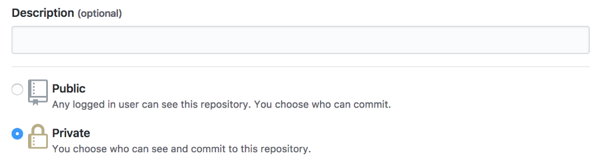

4) In order to share a private repository, you will need to add your mentor as a collaborator. In your repository settings, navigate to collaborators and add enter your mentor's email / name to add them as a collaborator.

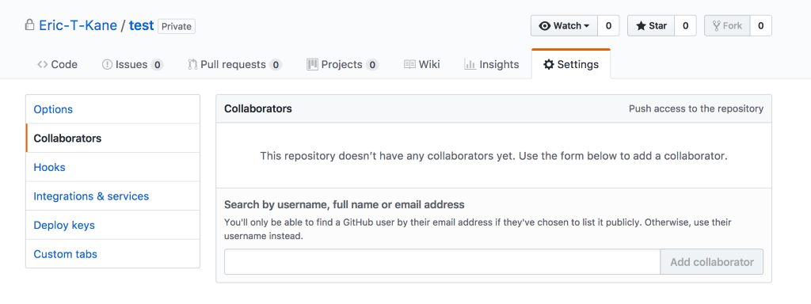

5) Now you should be able to share your GitHub URL in the Submission Document and your mentor will be able to access it.

You need to make sure you code is easily understood. For each component of the dashboard you should write specific procedures for how someone should read your code. You should provide detailed explanations in the README file (for example, provide details explaining how you completed the Yelp API view – where is the api call performed? How is the data manipulated? How did you create the bar chart? Etc.) and your code should be commented and clean.

**Note**

A major part of development is leveraging resources, such as stack overflow, medium, github, etc to research and find solutions to challenges you face. The internet is a big place and people have spent endless hours developing tutorials and answering specific coding questions on forums. When in doubt – google it.

**Here's a good resource:**

https://github.com/sunilake/Become-A-Full-Stack-Web-Developer